Name: _______________________

Joints and Bone Disorders Webquest
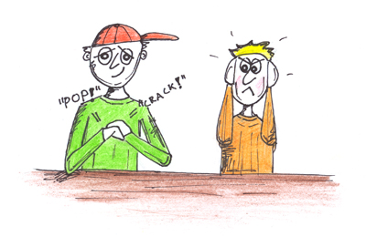

I. Classification of Joints
Go to http://www.wisc-online.com/objects/index_tj.asp?objID=AP11904
Joints can be classified based on their structure of function. The FUNCTIONAL classification is based on the amount of movement allowed at the joint.
- Diarthroses = __________ moveable
Description: _____________________________________________
2 examples: _____________________________________________

- Amphiarthroses = ____________ moveable
Description: _____________________________________________
2 examples: _____________________________________________

- Synarthroses = ___________ movement
Description: _____________________________________________
2 examples: _____________________________________________

Joints can also be classified based on their STRUCTURE.
Go to http://www.teachpe.com/anatomy/joints.php

- FIBROUS JOINTS:

Three Types:
1.

2.

3.

- CARTILAGENOUS JOINTS:

Two Types:
1.

2.

- SYNOVIAL JOINTS
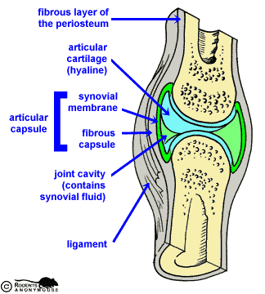

What’s the function of:

  - Articular cartilage:

  - Articular capsule:

  - Synovial fluid:

  - Ligaments:

  - Bursae:

http://legacy.owensboro.kctcs.edu/gcaplan/anat/Notes/API%20Notes%20I%20Types%20of%20Joints.htm

3. ACL Tear and Repair Go to
http://orthoinfo.aaos.org/topic.cfm?topic=a00549
What is the “ACL” and where is it located?

If the ACL is torn, how do you think this affects the movement of the knee?

Go to http://www.orthosports.com.au/swarm/knee/interactive_knee_acl.html
Click on “see step by step”. Briefly describe the procedure to repair a torn ACL.

4. Arthritis—Two Types

- Osteoarthritis http://www.medicinenet.com/osteoarthritis/article.htm

  - Description/Cause:

- Rheumatoid Arthritis
https://www.medicinenet.com/rheumatoid_arthritis/article.htm

Description of rheumatoid arthritis:

How does RA differ from OA?

5. Virtual Hip Surgery Your turn to be the doctor! Write a brief description of the steps involved in the surgery.
https://cdn.ymaws.com/edheads.org/resource/resmgr/activities/Hip_resurfacing/swf/index0.html


7. What’s up with the phrase “Double-Jointed”? Explain what this means…
https://www.realsimple.com/health/what-does-double-jointed-mean

8. Cracking knuckles and other assorted body parts… (be sure to visit BOTH sites)
http://www.livescience.com/health/060710_mm_joints_crack.html
http://www.physorg.com/news64162917.html

a. What are the different explanations behind what causes the “popping” sounds associated with joint-popping?

- Can cracking your knuckles cause arthritis? Explain.

Glossary
By the end of the lesson, define at least ten new vocabulary words you will need to know about this topic

Word | Definition

